**Predicting COVID-19 Cases in India Using ARIMA, Prophet, LSTM, and Data Analysis Using Power BI**

Abhrajit Das  
Seidenberg School of Computer Science and Information Systems, Pace University, USA  
abhrajit.breathin@gmail.com

**Abstract**

India confronted a serious challenge in the initial throes of the COVID-19 pandemic. This study addressed this by leveraging machine learning to analyse confirmed cases and support better decision-making. We compared the efficacy of Auto-Regressive Integrated Moving Average (ARIMA), Facebook Prophet, and Long Short-Term Memory (LSTM) models on a Kaggle dataset, visualizing the results with Power BI to forecast future trends. The LSTM model, evaluated using Mean Absolute Percentage Error (MAPE), demonstrated superior accuracy in predicting case numbers. This research underlines the importance of data analysis during public health emergencies. Machine learning offers valuable insights for policymakers, empowering them to control outbreaks and allocate resources effectively. Ultimately, this paves the way for strengthened public health responses and preparedness for future pandemics.

**Keywords:** Machine Learning, Time Series Forecasting, Data Science, Public Health, Data Visualization, Epidemiology.

**1. Introduction**

The first instance of Novel coronavirus, which is also known as the Wuhan Virus or COVID-19, was reported in the middle of December 2019. The human-to-human transmission of nCov or the Coronavirus raised infected cases exponentially in this early stage. The World Health Organization (WHO) issued a worldwide health emergency on 30 January 2020 because of COVID-19 [1]. Morbidity and mortality rates for COVID-19 infection are unknown at an advanced stage, particularly for young and old people [2]. To control the widespread of COVID-19, government authorities took preventative actions and enforced curfews or shut down infested cities in most of the world. This helps the public authorities to implement social distancing among the people to prevent the spread of this novel virus [3]. The emergence of the COVID-19 pandemic in late 2019 has swiftly evolved into a global health crisis, profoundly impacting populations, economies, and healthcare systems worldwide. Among the countries severely affected, India stands out due to its vast population and diverse socio-economic landscape [1-4]. From March to August 2020, India experienced a significant surge in COVID-19 cases, prompting stringent measures and public health interventions across various states to curb the spread of the virus [2-4]. This paper delves into the trajectory of COVID-19 in India during this critical period, focusing on data-driven analysis and predictive modelling using advanced machine-learning techniques [5]. The study employs comprehensive data sourced from Kaggle [4], covering essential metrics such as confirmed cases, deaths, and recoveries. These metrics were further analysed using Power BI [6-9], a powerful data visualization tool that enabled detailed insights into the pandemic's progression. The main contributions of the proposed work can be summarized as follows:

1. The research collected a comprehensive COVID-19 dataset from Kaggle (March to August 2020), serving as a robust foundation for time series analysis [10-12], detailed data visualization using Power BI, and model training using Python.

2. The study evaluates and compares ARIMA, Prophet, and LSTM models using Mean Absolute Percentage Error (MAPE) as the primary performance metric, demonstrating their applicability in real-world public health scenarios.

3. The proposed scheme has the potential to provide a predictive tool for assessing the status of COVID-19 infection and enable government and health workers to make better decisions to reduce mortality.

The structure of this paper is organized as follows: Section 2 reviews related work and theoretical background. Section 3 describes the data and methodology used for analysis and predictive modelling. Section 4 presents the results of the analysis, compares the performance of the predictive models, and discusses the implications of the findings for public health policy and future research. Finally, Section 5 concludes the paper and outlines potential directions for future work.

**2. Related Works**

While machine learning holds promise for predicting infectious disease outbreaks [13-23], existing research on COVID-19 forecasting in India has limitations. Many studies lack comprehensive comparisons of different models, particularly within the specific socio-economic and demographic context of India [5]. Additionally, existing research often does not consider how well models adapt to rapidly evolving data patterns during a pandemic. This study addresses these gaps by comparing the performance of three prominent machine learning models: ARIMA, Prophet, and LSTM. We evaluate their accuracy in forecasting COVID-19 cases in India and assess their ability to adapt to changing data trends. Furthermore, we acknowledge the importance of data visualization tools like Power BI in interpreting model predictions and informing public health decisions.

**3. Proposed Scheme**

The proposed scheme involves the implementation and comparison of three advanced machine learning models—ARIMA [15-17], Prophet [18-20], and LSTM [21-23] to predict the number of COVID-19 cases in India. Each model was meticulously trained and evaluated based on its accuracy in forecasting actual case counts. The primary performance metric used for this evaluation was the Mean Absolute Percentage Error (MAPE), which provides a clear measure of each model's predictive accuracy [24].

By comparing the performance of these models using MAPE, the study aimed to identify the most reliable and accurate predictive model. The evaluation process not only focused on the numerical accuracy of predictions but also considered the models' ability to adapt to evolving data patterns over time. This comprehensive analysis provided insights into the strengths and limitations of each model, contributing to a better understanding of their applicability in real-world public health scenarios. The results of this comparative analysis are intended to inform health consultants and policymakers about the most effective modeling techniques for predicting COVID-19 trends.

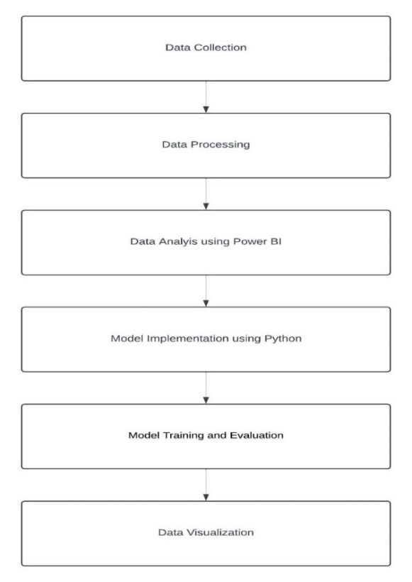

**Figure 1** Processing steps in the proposed methodology

**3.1 The ARIMA (Auto-Regressive Integrated Moving Average) Model** is a classic time series model known for its simplicity and effectiveness in capturing linear relationships in data. ARIMA, which stands for Auto Regressive Integrated Moving Average, is defined by three parameters: p, d, and q. The parameter p (Auto Regressive part) signifies the number of lag observations included in the model, essentially using past values to predict the current value [15]. The parameter d (Integrated part) indicates the number of times the raw observations are differenced to make the time series stationary, thus stabilizing the mean by eliminating trends and seasonality [16]. The parameter q (Moving Average part) represents the size of the moving average window, which smooths out the noise in the data by averaging past forecast errors. ARIMA models are particularly effective in scenarios where data exhibits linear trends and correlations over time, making them powerful tools for predicting short-term trends in various fields, including economics, finance, and epidemiology. Despite their simplicity, ARIMA models can provide robust forecasts when appropriately parameterized, offering valuable insights by decomposing time series into understandable components [17].

The equation for the model is as follows:

Yt = c + Φ1Yt-1 + Φ2Yt-2 + … + ΦpYt-p + θ1ϵt-1 + θ2ϵt-2 + …. + θqϵt-q + ϵt (1)

where,

Yt is the time series value at time t

c is a constant

Φ and θ are parameters

ϵ is white noise.

**3.2 Prophet Model** a time series model by Facebook, is adept at handling seasonality and holiday effects in time series data. Prophet is a decomposable time series model with three main components: trend, seasonality, and holidays [18]. The trend component captures the overall direction of the data over time, whether it is increasing, decreasing, or remaining stable. The seasonality component accounts for periodic patterns that repeat at regular intervals, such as daily, weekly, or yearly cycles. The holidays component incorporates the effects of holidays and special events that can cause significant deviations in the data. Prophet's strength lies in its ability to fit complex data patterns and make accurate forecasts by combining these components, making it particularly useful for scenarios where data is influenced by seasonal variations and specific events [19].

The equation for the model is as follows:

y(t) = g(t) + s(t) + h(t) + ϵt (2)

where,

g(t) is a piecewise linear or logistic growth curve for modelling non-periodic changes in time series.

s(t) is periodic changes (e.g., weekly/yearly seasonality).

h(t) is the effects of holidays that occur on potentially irregular schedules over one or more days [20].

**3.3 The LSTM (Long-Short Term Memory) Model** a type of recurrent neural network (RNN), stands out for its ability in sequence prediction tasks. This strength stems from its core component, the memory cell. Unlike traditional RNNs that struggle to remember information from earlier in a sequence, the LSTM's memory cell persists over time. This allows the model to retain crucial details and use them for future predictions [21]. This capability makes LSTMs particularly valuable for tasks where context and the order of information are essential, such as natural language processing, time series forecasting, and speech recognition. Additionally, LSTMs excel at overcoming the vanishing gradient problem that plagues traditional RNNs. This enables them to effectively learn from and make predictions based on lengthy data sequences. The combination of its memory capabilities and ability to handle long-term dependencies makes LSTMs a powerful tool for various applications, especially those involving complex patterns within data sequences [22].

The equations for the model are as follows:

It = σ(Wi.[ht-1,xt] + bi) (3)

ft = σ(Wf.[ht-1,xt] + bf) (4)

ot = σ(Wo.[ht-1,xt]+bo) (5)

C̃t = tanh(Wc.[ht-1,xt]+bC) (6)

Ct = ft.Ct-1 + it.C̃t  (7)

ht = ot.tanh(Ct) (8)

where,

it, ft, ot​ are the input, forget, and output gates respectively,

C̃t is the cell state,

Ct is the updated cell state,

ht is the hidden state [23].

**3.4 MAPE (Mean Absolute Percentage Error)** is a widely used metric for measuring the accuracy of a forecast or prediction model. It is particularly valued for its simplicity and interpretability, providing a percentage error that indicates the average deviation of the predicted values from the actual values. This makes it easier to understand and communicate the performance of a model in practical terms. MAPE is calculated as the average of the absolute percentage errors between the actual and predicted values. It quantifies the accuracy of a model as a percentage, giving an intuitive sense of how far off the predictions are from the actual values on average [24].

The formulae for MAPE is:

MAPE = $\frac{1}{n}\sum_{t=1}^{n}{\left|\frac{A_{t}-F_{t}}{A_{t}}\right|X 100}$ (9)

where,

n is the number of observations.

At represents the actual value at time t.

Ft represents the forecasted (predicted) value at time t.

$\left|\frac{A_{t}-F_{t}}{A_{t}}\right|$ denotes the absolute value.

MAPE = 0% indicates Perfect accuracy, the predicted values exactly match the actual values.

Lower MAPE indicates better model accuracy, as the average percentage error is smaller.

Higher MAPE indicates poorer model accuracy, as the average percentage error is larger.

**4. Performance Analysis**

**4.1 Experimental Setup**

The study utilized the following configuration for model development and analysis:

**Hardware:**

* RAM: 16 GB
* Processor: 11th Gen Intel(R) Core(TM) i5-1135G7 @ 2.40GHz
* Operating System: Windows 11

**Software:**

* Python 3.8
* Jupyter Notebook for model development and execution
* Power BI [6] for Data Visualization

The experiment involved preprocessing the data to prepare it for modelling. This likely included cleaning, handling missing values, and potentially feature engineering. Following preprocessing, the chosen machine learning models were implemented in Python within the Jupyter Notebook environment.

**4.2. Dataset Overview**

This study utilizes a COVID-19 dataset encompassing daily cases, deaths, and recoveries across 28 Indian states and 8 union territories (March-August 2020). With 5,694 entries, it offers granular-level insights for analysis and forecasting models, crucial for understanding the pandemic's progression and evaluating prediction models' effectiveness [4].

**4.3 Results and Discussions**

This study analysed COVID-19 data in India from March to August 2020, employing various techniques for exploration, visualization, and prediction. A Power BI dashboard (Figure 2) served as the central hub for data exploration, offering functionalities like time series analysis, state-wise breakdowns, and future predictions (Figure 3). This interactive platform facilitated understanding trends, hotspots, geographical spread, and the impact of interventions.

The analysis revealed significant regional variations in COVID-19 cases. Maharashtra emerged as the most affected state (479,779 cases), likely due to factors like population density and healthcare disparities [1-4]. Conversely, states with lower population densities or proactive containment measures generally reported fewer cases. Peak periods highlighted critical moments of heightened transmission, informing resource allocation for future outbreaks.

Three machine learning models (ARIMA, Prophet, LSTM) were employed to forecast confirmed COVID-19 cases for July 13 to August 6, 2020 (Table 1). The LSTM model achieved the highest accuracy (MAPE: 0.0617) due to its ability to capture complex patterns (Figure 6) compared to ARIMA (MAPE: 0.375, Figure 4) and Prophet (MAPE: 0.228, Figure 5). While Prophet effectively handled seasonality (advantageous for COVID-19 forecasting) [18-20], LSTM's strength lies in capturing long-term dependencies and non-linearities, crucial for accurate predictions [21-23].

Overall, this study highlights the potential of Power BI for data exploration and visualization, and machine learning, particularly LSTM, for forecasting COVID-19 cases. These tools can be valuable assets for public health officials in understanding the pandemic's dynamics, planning interventions, and allocating resources effectively. Continuous monitoring and adaptation of strategies remain essential, as unforeseen circumstances can influence forecasts [5].

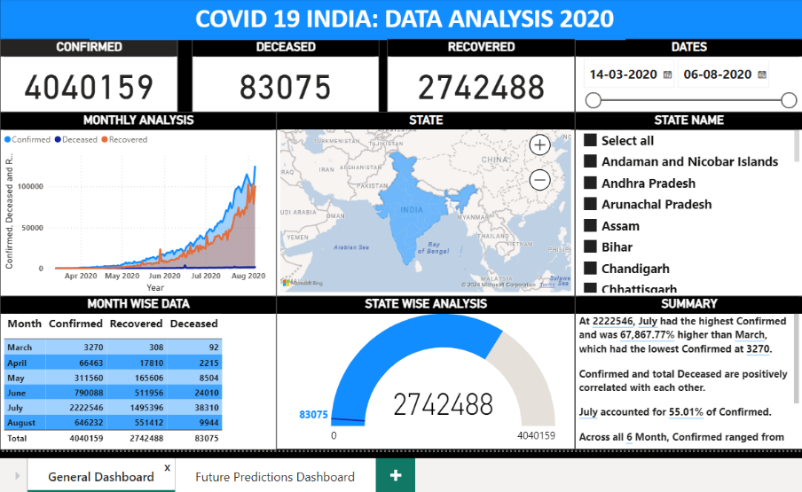

**Figure 2.** COVID-19 Interactive Dashboard on Power BI showcasing Time Series Analysis, Geographical Heat Maps, Comparative Analysis, and Trend Analysis.

**4.4 Exploratory Data Analysis (EDA) and Data Visualization with Power BI**

A Power BI dashboard effectively visualized COVID-19 data (Figure 2), offering an interactive interface for exploring trends, hotspots, and geographical spread over time. Users could filter data by specific timeframes and locations, providing a granular view of the pandemic's progression. Highlighting key metrics and trends, the dashboard aided in understanding the impact of interventions and pinpointing periods of rapid case increases. This visualization tool proved essential for health officials and researchers, providing actionable insights to guide public health strategies and resource allocation. It also fostered public awareness by disseminating critical information. Furthermore, the dashboard offered functionalities for future prediction (Figure 3), allowing users to forecast the number of confirmed, recovered, and deceased cases. Additionally, a decomposition tree facilitated detailed analysis by breaking down total confirmed cases by month and state name. Overall, the Power BI dashboard enhanced data transparency and data-driven decision-making during the pandemic. Key features of the Power BI dashboards included:

**Monthly Analysis:** Visualizing the daily trends in confirmed cases, deaths, and recoveries to understand the progression of the pandemic.

**State-wise Analysis:** Identifying peaks and troughs in case numbers to pinpoint critical transmission periods.

**Detailed Summary:** Provided detailed summary of the entire dashboard.

**Future Predictions**: Forecasting the number of confirmed, recovered, and deceased cases for the future (Figure 3).

**Decomposition Tree**: Breaks down total confirmed cases by month and state name for detailed analysis.

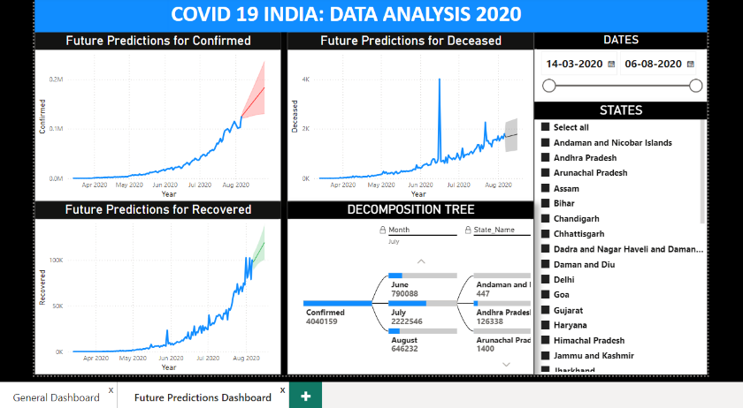

**Figure 3.** Dashboard for Future Predictions of COVID-19 Cases in India: Confirmed, Deceased, and Recovered

**4.5 COVID-19 Impact and Statistical Summary**

During the period from March to August 2020, India reported a total of 4,040,159 confirmed COVID-19 cases, with 83,075 deaths and 2,742,488 recoveries. Maharashtra emerged as the most severely affected state, recording 479,779 confirmed cases, 16,791 deaths, and 320,893 recoveries, followed by Tamil Nadu with 273,969 confirmed cases, 4,456 deaths, and 215,056 recoveries. The analysis reveals variations in COVID-19 impact across states in India. States like Maharashtra, Tamil Nadu, and Delhi reported the highest total confirmed cases, reflecting the regional disparities in healthcare infrastructure and population density [1-4]. On the other hand, states with lower population densities or proactive containment measures generally recorded fewer cases and deaths. The peak values highlight critical periods of transmission and healthcare strain, guiding resource allocation and policy interventions. The future predictions in Figure 3 suggested that there would be a significant rise in the number of confirmed and recovered cases with a minimal increase in deceased cases over time, but limitations exist as unforeseen circumstances can influence forecasts. Continuous monitoring and adaptation of public health strategies remain paramount in mitigating the pandemic's impact [3].

**Table 1.** Comparison of Actual and Predicted Values for ARIMA, Prophet, and LSTM Models

|  |  |  |  |  |
| --- | --- | --- | --- | --- |
| Date | Actual Data | ARIMA Predicted | Prophet Predicted | LSTM Predicted |
| 2020-07-13 | 56356 | 47795 | 51738 | 58761 |
| 2020-07-14 | 59834 | 47795 | 53145 | 60911 |
| 2020-07-15 | 65214 | 47795 | 54707 | 63083 |
| 2020-07-16 | 70936 | 47795 | 56046 | 64875 |
| 2020-07-17 | 69640 | 47795 | 57016 | 67295 |
| 2020-07-18 | 74822 | 47795 | 58619 | 69363 |
| 2020-07-19 | 80470 | 47795 | 59306 | 72009 |
| 2020-07-20 | 73612 | 47795 | 58763 | 74870 |
| 2020-07-21 | 78340 | 47795 | 60080 | 78010 |
| 2020-07-22 | 91202 | 47795 | 61641 | 80784 |
| 2020-07-23 | 96886 | 47795 | 62981 | 83525 |
| 2020-07-24 | 97776 | 47795 | 63950 | 86164 |
| 2020-07-25 | 100144 | 47795 | 65553 | 89546 |
| 2020-07-26 | 97864 | 47795 | 66241 | 92565 |
| 2020-07-27 | 92968 | 47795 | 65607 | 94900 |
| 2020-07-28 | 99262 | 47795 | 67014 | 98031 |
| 2020-07-29 | 104958 | 47795 | 68576 | 100625 |
| 2020-07-30 | 109936 | 47795 | 69915 | 101805 |
| 2020-07-31 | 114972 | 47795 | 70885 | 102666 |
| 2020-08-01 | 110234 | 47795 | 72488 | 103904 |
| 2020-08-02 | 105344 | 47795 | 73175 | 104937 |
| 2020-08-03 | 100976 | 47795 | 72542 | 106148 |
| 2020-08-04 | 102564 | 47795 | 73949 | 107699 |
| 2020-08-05 | 102774 | 47795 | 75510 | 108378 |
| 2020-08-06 | 124340 | 47795 | 76850 | 108289 |

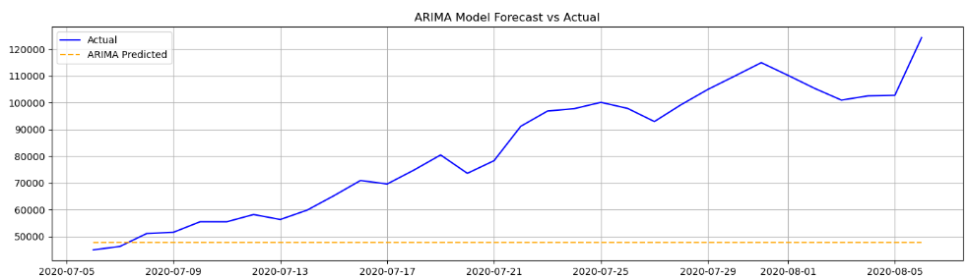 **Figure 4.** Comparison of Actual vs Predicted Daily Confirmed COVID-19 Cases in India using ARIMA Model

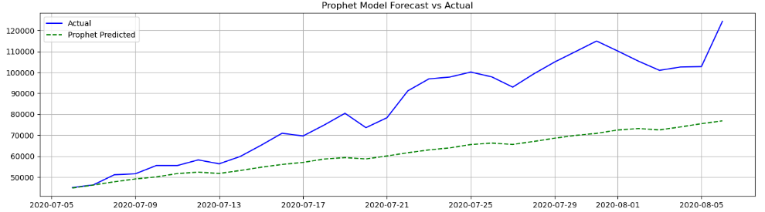**Figure 5.** Comparison of Actual vs Predicted Daily Confirmed COVID-19 Cases in India using Prophet Model

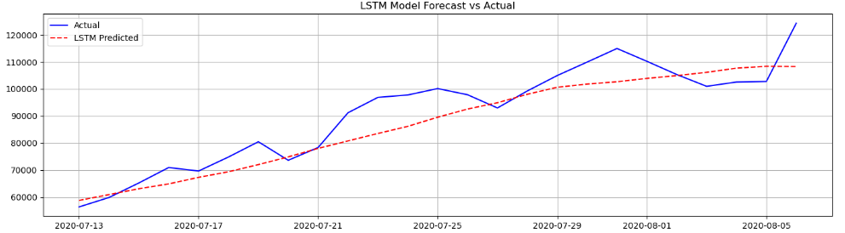**Figure 6.** Comparison of Actual vs Predicted Daily Confirmed COVID-19 Cases in India using LSTM Model

**4.6 Machine Learning Models**

Table 1 represents a detailed comparison of the actual versus predicted values for confirmed COVID-19 cases in India. This comparison spans the period from July 13, 2020, to August 6, 2020, and utilizes three different predictive models: ARIMA, Prophet, and LSTM. Each row is dedicated to one of these models, showcasing the effectiveness and accuracy of the predictions during this specified timeframe. Figures 4, 5 and 6 illustrate the actual versus predicted trends of confirmed COVID-19 cases in India from July 13, 2020, to August 6, 2020. These figures depict line graphs where the x-axis represents the dates within this range, and the y-axis indicates the number of confirmed COVID-19 cases. Figures 4, 5, and 6 all depict predicted values (orange in Figure 4, green in Figure 5, and red in Figure 6) compared to the actual values (blue in all figures).

**4.7 ARIMA Model** demonstrated moderate performance in predicting the number of confirmed COVID-19 cases in India. It was effective in capturing linear trends and short-term variations within the dataset. However, the model encountered difficulties when dealing with non-linear patterns and seasonal fluctuations, which affected its accuracy in making long-term forecasts. Despite these challenges, the ARIMA model achieved a Mean Absolute Percentage Error (MAPE) of 0.375. This indicates that while the model was somewhat effective in capturing general trends, it fell short when it came to making precise predictions. Figure 4 and Table 1 detail the ARIMA model's performance metrics and insights, offering a comprehensive view of its strengths and weaknesses in prediction. [15-17].

**4.8 Prophet Model** exhibited robust performance in forecasting the number of confirmed COVID-19 cases in India. One of its key strengths is its ability to effectively handle seasonality and holiday effects, which are critical factors in accurately modelling the spread of the virus. The model achieved a Mean Absolute Percentage Error (MAPE) of 0.228, 15 indicating a significant improvement over the ARIMA model. Prophet excelled in capturing both short-term fluctuations and long-term trends, demonstrating its flexibility in modelling complex data patterns. This flexibility contributed to its superior accuracy in predicting the dynamics of COVID-19, making it a reliable tool for understanding and forecasting the pandemic's progression. Figure 5 and Table 1 together illuminate the Prophet model's performance and insights, highlighting its effectiveness relative to other models. [18-20].

**4.9 LSTM Model** emerged as the most accurate model for forecasting the number of confirmed COVID-19 cases in India. Leveraging its advanced capacity to capture non-linear dependencies and long-term trends, LSTM demonstrated exceptional performance in predicting the dynamics of the pandemic. The model achieved a Mean Absolute Percentage Error (MAPE) of 0.0617, surpassing both the ARIMA and Prophet models in terms of accuracy. This low MAPE indicates the LSTM model's high precision in forecasting. Its ability to learn from historical data and adapt to evolving trends was instrumental in accurately predicting COVID-19 case numbers across different states. Figure 6 and Table 1 showcase the LSTM model's superior predictive capabilities [21-23].

**5. Conclusion and Future Work**

This study explored India's initial COVID-19 wave (March-August 2020). Power BI empowered researchers with data exploration and visualization, uncovering regional variations in cases linked to population density and healthcare disparities. Power BI's forecasting functionalities were also explored, providing initial predictions for future trends. Further analysis employed machine learning models to refine case forecasts. The LSTM model emerged as the most accurate (MAPE: 0.0617), surpassing ARIMA and Prophet due to its ability to handle complex patterns. The LSTM model's accuracy suggests its potential to inform public health strategies and resource allocation during future outbreaks.

Future research could refine models with additional data (demographic, socio-economic) and explore ensemble techniques for enhanced accuracy. Real-time data integration and scenario-based simulations could provide valuable insights for pandemic response strategies.

**References**

1. World Health Organization (WHO): Coronavirus disease (COVID-19) pandemic. Available at: https://www.who.int/emergencies/diseases/novel-coronavirus-2019 (2020).
2. Eissa, D., Rashed, E., Eissa, M.: A Study of Morbidity and Mortality from COVID-19 in India. SciMedicine Journal 4, 25-38 (2022). doi:10.28991/SciMedJ-2022-0401-03.
3. Makandar, S., Prabhakar, S.: COVID-19 Lockdown in India and its impact on people’s livelihoods. PalArch's Journal of Archaeology of Egypt/Egyptology 18, 381-388 (2021).
4. Imdevskp: COVID-19 India State-wise dataset for confirmed, deceased, and recovered from March 2020 to August 2020. Available at: <https://www.kaggle.com/datasets/imdevskp/covid19-corona-virus-india-dataset?select=state_level_daily.csv>
5. Sah, S., Surendiran, B., Dhanalakshmi, R., Mohanty, S., Alenezi, F., Polat, K.: Forecasting COVID-19 Pandemic Using Prophet, ARIMA, and Hybrid Stacked LSTM-GRU Models in India. Computational and Mathematical Methods in Medicine 2022, 1-19 (2022). doi:10.1155/2022/1556025.
6. Microsoft Corporation: Power BI Documentation. Available at: <https://docs.microsoft.com/en-us/power-bi/> (2020).
7. Abinaya, S.: Data Visualization Using Power BI. International Scientific Journal of Engineering and Management 3, 1-9 (2024). doi:10.55041/ISJEM01536.
8. Aravinthan, B.: Property Future Price Estimation Using ML, Power BI Time Series Analysis and Forecasting. International Journal of Science and Research (IJSR) 13, 619-622 (2024). doi:10.21275/SR24330134715.
9. Rajput, S.: Comparison between Tableau and Power BI: A Case Study of COVID-19. International Journal of Scientific Research in Engineering and Management 8, 1-5 (2024). doi:10.55041/IJSREM32733.
10. Namasudra, S., Dhamodharavadhani, S., Rathipriya, R. G., Crespo,

R. G., Moparthi, N. R.: Enhanced neural network-based univariate time

series forecasting model for big data. Big Data (2023).

doi:10.1089/big.2022.0155

1. Box, G. E. P., Jenkins, G. M., Reinsel, G. C.: Time Series Analysis: Forecasting and Control. John Wiley & Sons, New York (1994).
2. Makridakis, S., Wheelwright, S. C., Hyndman, R. J.: Forecasting: Methods and Applications. 3rd edn. John Wiley & Sons, New York (1998).
3. Dua, D., Graff, C.: UCI Machine Learning Repository. University of California, Irvine, School of Information and Computer Sciences. Available at: <http://archive.ics.uci.edu/ml> (2019).
4. Pedregosa, F., et al.: Scikit-learn: Machine Learning in Python. Journal of Machine Learning Research 12, 2825-2830 (2011).
5. Singh, S., Parmar, K., Kumar, J., Kaur, J.: Prediction of Confirmed, Recovered and Casualties’ Cases of COVID-19 in India by Autoregressive Integrated Moving Average (ARIMA) Models. In: Proceedings of the International Conference on Intelligent Systems and Signal Processing, pp. 305-312. Springer, New York (2022). doi:10.1007/978-3-030-72834-2_6.
6. Alzahrani, S., Saadeh, R., Abdoon, M., Qazza, A., Guma, F., Berir, M.: Numerical Simulation of an Influenza Epidemic: Prediction with Fractional SEIR and the ARIMA Model. Applied Mathematics & Information Sciences 18, 1-12 (2024). doi:10.18576/amis/180101.
7. Namasudra, S., Dhamodharavadhani, S., Rathipriya, R.: Nonlinear neural network-based forecasting model for predicting COVID-19 cases. Neural Processing Letters (2021). doi:10.1007/s11063-021-10495-w.
8. Kapse, P., Timande, P., Bramhankar, A., Rewatkar, S., Khandait, S.: Analysis & Prediction of COVID-19 using Prophet Model. International Journal for Research in Applied Science and Engineering Technology 10, 1352-1356 (2022). doi:10.22214/ijraset.2022.42481.
9. Tulshyan, V., Sharma, D., Mittal, M.: An Eye on the Future of COVID'19: Prediction of Likely Positive Cases and Fatality in India over A 30 Days Horizon using Prophet Model. Disaster Medicine and Public Health Preparedness 16 (2020). doi:10.1017/dmp.2020.444.
10. Kumar, P., Sharma, R., Singh, S.: Predictive Analysis of Real-Time Strategy using Facebook’s Prophet Model on COVID-19 Dataset of India. Journal of Pharmaceutical Research International 33(51A), 305-312 (2021). doi:10.9734/jpri/2021/v33i51A33496.
11. Hochreiter, S., Schmidhuber, J.: Long Short-Term Memory. Neural Computation 9(8), 1735-1780 (1997).
12. Chandra, R., Jain, A., Chauhan, D.: Deep learning via LSTM models for COVID-19 infection forecasting in India (2021).
13. Hochreiter, S., Schmidhuber, J.: Long short-term memory. Neural Computation 9(8), 1735-1780 (1997).
14. Robeson, S., Willmott, C.: Decomposition of the mean absolute error

(MAE) into systematic and unsystematic components. PLoS ONE 18,

e0279774 (2023). doi:10.1371/journal.pone.0279774